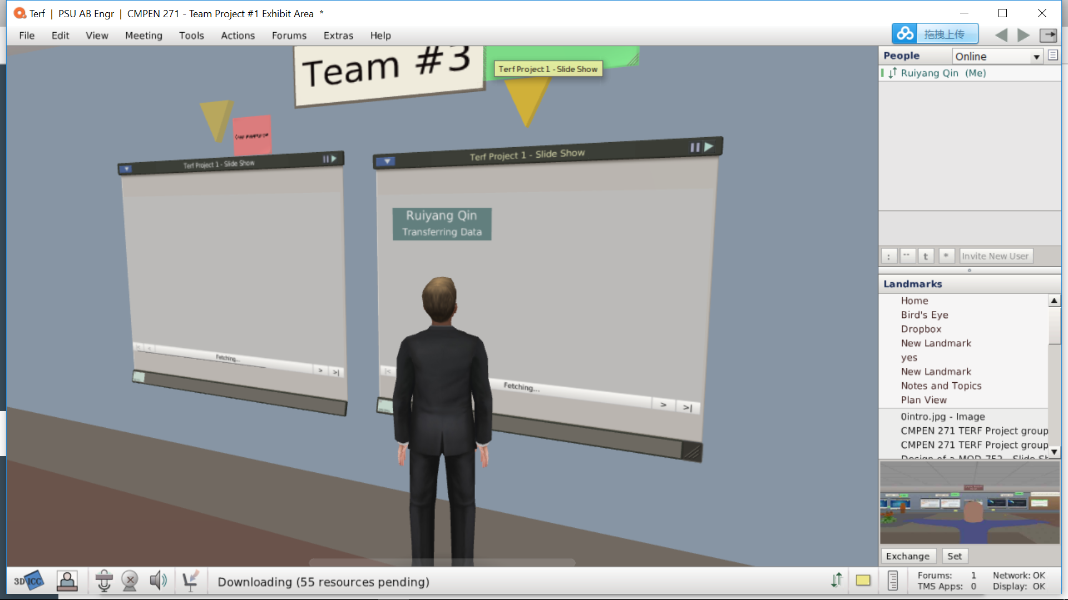

Well, I think post a project in Terf will allow people are enrolled in online course to meet online at the same time. It’s a good way to know each other better. Also, it will make students feel this course is more like the offline course. But just like what happen on me, by some personal business, I cannot be there on time. It’s also highly possible to forget the meeting because it’s only one time meeting, not regular time. Honestly, I still think individual working will be better for online course. Group project is hard even for course in person because members have different schedule and academic plans or works to do~